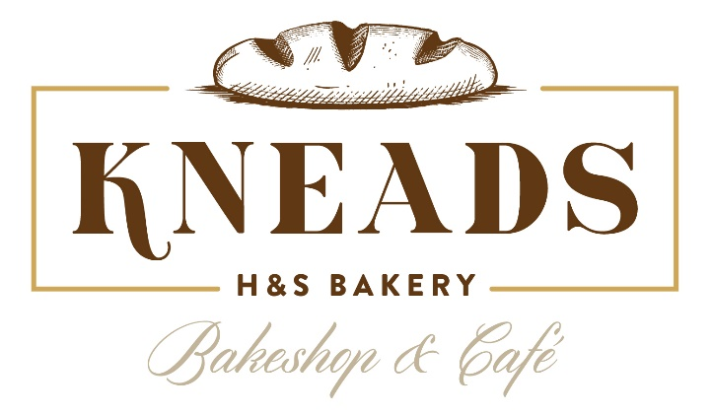
Breakfast Shareables

Kneads Bagel Platter | $55
A dozen assorted or plain bagels, served cream cheese, butter and jelly.
Breads and Spreads | $65
Chef’s daily selection of four artisan breads. Comes paired with whipped butter, preserves & accoutrements.
Viennoisrie Platter | $60
A dozen assorted croissants, chocolate croissants, and bear claws. Baked fresh daily!
Danish Medley | $60
A dozen fresh baked blueberry, cream cheese Danish and pastries.
Premium Doughnut Platter | $50
A dozen assorted freshly prepared doughnuts. A mix of chocolate dipped, vanilla dipped, cinnamon sugar, maple bacon, raspberry sprinkle and glazed.
Gourmet Doughnut Platter | $60
A dozen assorted freshly made stuffed doughnuts. An assortment of our Baltimore Brew, Strawberry Cheesecake, Seasonal Flavor and Crème Brulé.

Personalized Breakfast
(Minimum order of 10)
Bagel Breakfast Box (V) | $15
Fluffy cage free souffle egg sandwich, smoked cheddar cheese served on our house made bagel. Sandwich accompanied with fresh fruit and Kneads doughnut holes.
*Add Bacon or House made Sausage +3
Gourmet Croissant Breakfast Box (V) | $17
Our famous buttery croissant topped with fluffy cage free souffle eggs and smoked cheddar cheese. Sandwich accompanied with fresh fruit and Kneads doughnut holes.
*Add Bacon or Sausage +3
Overnight Oats Box (V) | $16
Rolled oats with coconut, chai seed, cinnamon, and seasonal preserves. Served with fresh fruit and Kneads doughnut holes.

KNEAD’ed Add-Ons
Aveley Roasters Kneads Blend Barista Box | $30
96 oz and served with cream and sugar. Serves 10-12.
Bottled Water | $20
12 Pack
Natalie’s fresh pressed orange juice | $12
4 pack of 8 oz. juice.
Natalie’s assorted fresh pressed juices | $20
4 pack of 16 oz. juice.
Greek Yogurt Parfait (V) | $7
Seasonal Fruit and Spices, Greek Yogurt, Granola and Honeycomb. (Minimum of 3)
Overnight Oats (V) | $9
Rolled Oats with Coconut, Chai Seed, Cinnamon, and Seasonal Preserves. (Minimum of 3)
Fresh Fruit Cup (V) | $6
4 oz fresh cut seasonal fruit medley. (Minimum 3)

Lunch Shareables
Serves 10
Kneads Café Deli Platter | $155
A trio of our homemade Bakeshop Chicken salad, Kneads egg salad, and Tuna salad. Served with artisan bread.
Chef’s Charcuterie Lunch | $170
Sliced Parisian Ham, Smoked Turkey, Mortadella & Provolone Cheese. Served with fresh baked brioche buns and accoutrements.
Breads and Spreads | $60
Chef’s selection of 4 daily made breads. Comes paired with whipped butter, preserves & accoutrements.
Fresh Fruit Bowl | $95
Chef’s selection of fresh seasonal fruit bowl.
Caesar Salad | $100
Baby Romaine with sourdough croutons, cured lemon and bonito Caesar dressing.
Greek Salad | $120
Karma Farm greens tossed with kalamata olives, sundried tomatoes, feta cheese, red onion & traditional Greek dressing.
Premium Party Sliders | $120
Party platter with 30 gourmet fresh baked slider rolls topped with your choice of Chicken Salad, Smoked Turkey and Cheese, Chefs Italian Cold Cut Slider, Ham and Cheese or do a Combo Platter 10 of each.
Pizza Assortment | $100
Kneads homemade pizza dough baked with the freshest locally sourced toppings.
Guest can choose 5 from below:
Kneads homemade pizza dough baked with the freshest locally sourced toppings. The assortment includes:
Margherita Pizza- Stracciatella, fresh handmade mozzarella, marinara, basil, evoo & maldon salt (ve)
Bianca- Cello, Bufala mozzarella, Fontina, Gorgonzola dolce, Oregano, Roasted garlic, red onion (ve)
Sausage & Broccolini- Italian pork sausage, Smoked mozzarella, Crushed chili & Fried sage
Spicy Salami- Calabrian Chili, Calabrese Salami, Basil & Bufala mozzarella
Veggie- Seasonal local farm-fresh veggies, Basil pesto & Grana

Personalized Lunch
(Minimum order of 10)
Premium Lunch Box | $20
Your choice of sandwich served on our daily fresh baked bread accompanied with gourmet potato chips and a homemade Chocolate Chunk Cookie.
- Chicken Salad Sandwich
- Oven Roasted Turkey Sandwich
- Parisian Ham Sandwich
- BLT with Heirloom Tomatoes
- Burrata Caprese

Gourmet Lunch Salad Bowl | $17
Kneads uses only locally sourced, farm to table produce handpicked by our Chef. Served with a chocolate chunk cookie. (add chicken $4)
- Caesar Salad (V)
  - Baby romaine, Kneads croutons, cured lemon and bonito Caesar dressing.
- Wedge Salad
  - Crisp Iceberg Wedge, chunks of smoked bacon, blue cheese crumbles and homemade ranch dressing.
- Greek Salad (V)
  - Mixed olives, feta, tomato, cucumber, peppers, Karma Farms lettuce & Kneads Bakeshop traditional Greek dressing.

KNEAD’ed Add-Ons
Aveley Roasters Kneads Blend Barista Box | $30
96 oz and served with cream and sugar. Serves 10-12.
Bottled Water | $20
12 Pack
Natalie’s fresh pressed orange juice | $12
4 pack of 8 oz. juice.
Natalie’s assorted fresh pressed juices | $20
4 pack of 16 oz. juice.
Greek Yogurt Parfait (V) | $7
Seasonal Fruit and Spices, Greek Yogurt, Granola and Honeycomb. (Minimum of 3)
Overnight Oats (V) | $9
Rolled Oats with Coconut, Chai Seed, Cinnamon, and Seasonal Preserves. (Minimum of 3)
Fresh Fruit Cup (V) | $6

Bakeshop BUN’dles
(Serves 10)

Lite Fare Morning | $100
Fresh seasonal fruit bowl and our daily baked assorted Danishes.
Continental Breakfast | $80 Assorted Danishes & a 96 oz. Aveley Kneads blend Barista Box.
Morning Pick-Me-Up | $75
Fresh made assorted doughnut hole tray and 96 oz. Aveley Kneads blend Barista Box.
Breakfast Feast | $200
Bagels and spreads, traditional & chocolate croissants, mixed Danishes, traditional doughnuts and doughnut hole assortment & a 96 oz. Aveley Kneads Blend Barista Box.
Afternoon Sweet Treat | $85
An Assortment of Kneads fresh baked cookies. Enjoy chocolate chip chunk, double chocolate s’mores, and strawberries & cream snickerdoodle cookies. Accompanied with Kneads doughnut holes.
Lunch Picnic Platter | $325
Every Party KNEADS this crowd pleaser. A trio of Chicken salad, Tuna Salad and Egg salad served with fresh sliced bread. Includes Lettuce and Tomato. Comes with fresh baked brioche rolls and your choice of a Caesar or Greek Salad. Can’t end without something sweet! Enjoy a platter of Kneads doughnut holes and 12 pack of water.

*Delivery available 7 days a week
*10% Packaging Fee added to every order
*Any Questions please email Kristin.graham@kneadsbakeshop.com

